PRINCE SULTAN UNIVERSITY

A Platform for Student Team Formation and Collaboration
PROJECT CHARTER
Senior Project
Prepared by
Asayil Al Luhayb — 222410382 — SE-AI
Nisreen Almutairi — 221511326 — SE-CYS
Fajer Alkhamash — 221410091 — SE-AI
Afnan Almuallim — 219410692 — SE-CYS
Shouq Almashouq — 221410803 — SE
Project Supervisor
Dr. Basmah Alkanjr

1. Sprint Duration and Dates
- Sprint duration: Four weeks - academic weeks 5–8.
- Start date: 12th September 2026
- End date: 1st October 2026

2. Sprint Goal
Deliver the foundation of Takatuf so students can create accounts and Skill Passports, publish project and event opportunities, and manage initial team recruitment. By the end of the sprint, a student should be able to discover an opportunity, submit an application, and have it reviewed and shortlisted by the request owner.

3. User Stories to Be Implemented
ID | User story
US01 - Account access | As a student, I want to create and access an account so that I can manage my participation.
US02 - Skill Passport and privacy | As a student, I want to describe my capabilities and control who sees my information so that I can present myself to potential teams.
US03 - Project recruitment listing | As a project owner, I want to publish the roles and commitment my project needs so that suitable students can apply.
US04 - Competition and hackathon listing | As a student, I want to share a competition or hackathon so that other students can discover it.
US05 - Event-linked team request | As a student entering an event, I want to create a linked team request so applicants understand the opportunity and recruitment needs.
US06 - Discover and save opportunities | As a student, I want to search and save opportunities so that I can decide where to participate.
US07 - Apply and withdraw | As a student, I want to apply to a team and withdraw when necessary so that my interest remains accurate.
US08 - Review applicants | As a team owner, I want to review and shortlist applicants so that I can organize recruitment decisions.

4. Tasks to Be Implemented
Task | Development work | Related stories
T01 - Application foundation | Set up the Android project, Python backend, relational database, API structure, and shared error responses. | US01–US08
T02 - Account access | Implement registration, password hashing, sign-in, protected sessions, sign-out, and account recovery using expiring reset tokens. | US01
T03 - Skill Passports | Build profile forms and endpoints for skills, proficiency, interests, experience, availability, and evidence links. Enforce visibility settings. | US02
T04 - Project recruitment | Implement project listing creation and editing, recruitment details, requested roles, vacancies, and editable role templates. | US03
T05 - Event listings | Implement competition and hackathon forms, organizer and source information, date validation, eligibility details, and expired-event labels. | US04
T06 - Event-linked requests | Connect team requests to existing event listings and display the event’s rules alongside recruitment details. | US05
T07 - Discovery and saved listings | Build search, filters, listing details, saved opportunities, and empty-result states. | US06
T08 - Applications | Implement submission, withdrawal, application status, duplicate prevention, and checks for closed requests. | US07
T09 - Applicant review | Build owner-only applicant lists and shortlist controls, applying profile visibility rules when displaying applicant information. | US08
T10 - Integration and testing | Test the complete discovery-to-shortlisting journey, invalid inputs, expired sessions, privacy settings, and unauthorized requests. | US01–US08
T11 - Matching feasibility experiment | Use a small synthetic dataset to check whether the proposed skill, role, and availability fields support basic applicant scoring. Record findings for Sprint 02. | Preparation for FR11

5. Functional Requirements Covered
- FR01 - Account access: Registration, sign-in, sign-out, and account recovery.
- FR02 - Skill Passports: Skills, proficiency, interests, experience, availability, and optional evidence.
- FR03 - Profile visibility: Controlled access to profile information.
- FR04 - Project listings: Project outcomes, required roles, commitment, and vacancies.
- FR05 - Competition and hackathon listings: Organizer, source, dates, eligibility, and team-size rules.
- FR06 - Event-linked team requests: Recruitment requests associated with a competition or hackathon.
- FR07 - Opportunity discovery: Search, filters, and saved listings.
- FR08 - Role templates: Editable templates for recruitment roles.
- FR09 - Applications: Application submission and withdrawal.
- FR10 - Applicant management: Application review, shortlisting, and status tracking.
The matching experiment is a development investigation supporting FR11. User-facing matching functionality is scheduled for Sprint 02.

6. Class Diagram
This diagram presents the main domain classes. Their operations describe responsibilities implemented through the Python backend. Session and password-reset classes support account access.
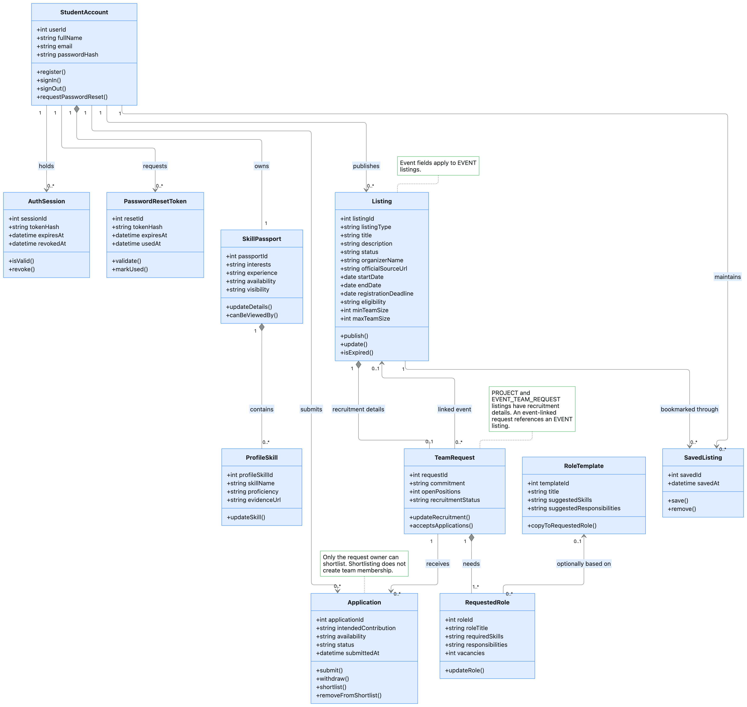
Figure 1. Sprint 01 class diagram showing account access, Skill Passports, opportunity listings, recruitment requests, and applications.

7. Sequence Diagrams

7.1 Student Sign-In
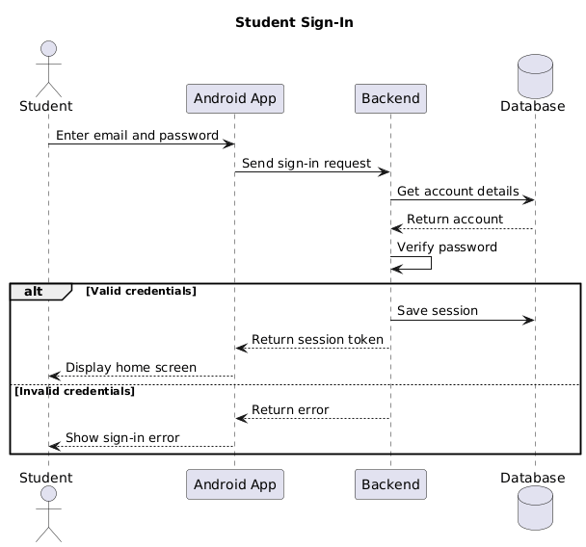
Figure 2. Sign-in sequence showing input validation, password verification, and secure session creation.

7.2 Create or Update a Skill Passport
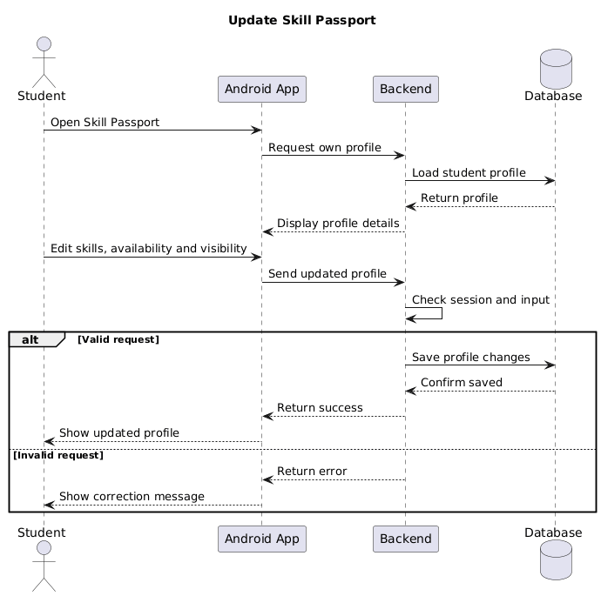
Figure 3. Skill Passport update sequence, including validation, privacy settings, and consistent profile storage.

7.3 Publish an Event-Linked Team Request
The owner selects an event that has already been published in the platform.
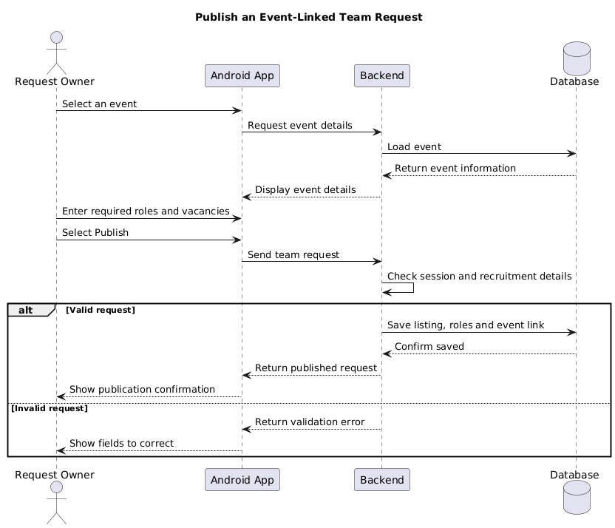
Figure 4. Event-linked team request sequence showing template use, event validation, and publication.

7.4 Discover an Opportunity, Apply, and Withdraw
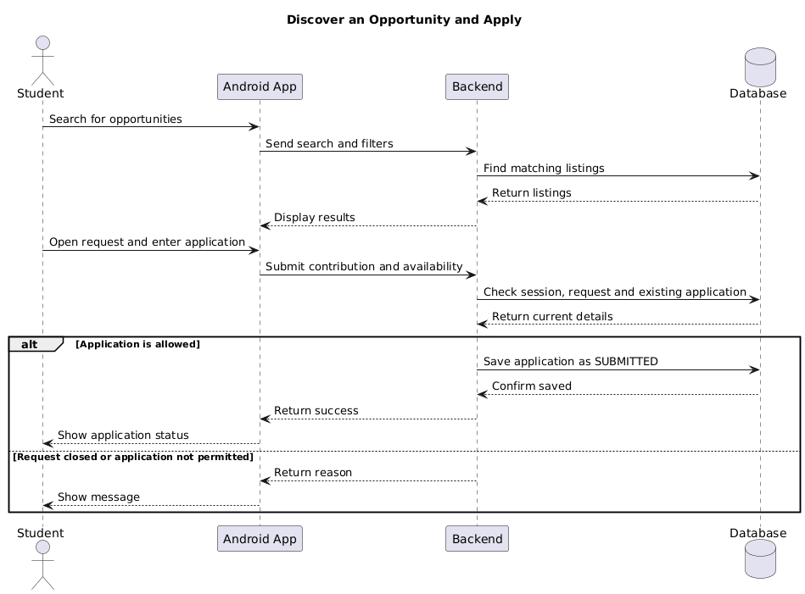Figure 5. Opportunity discovery and application sequence, including saved listings, duplicate checks, and withdrawal.

7.5 Review and Shortlist Applicants
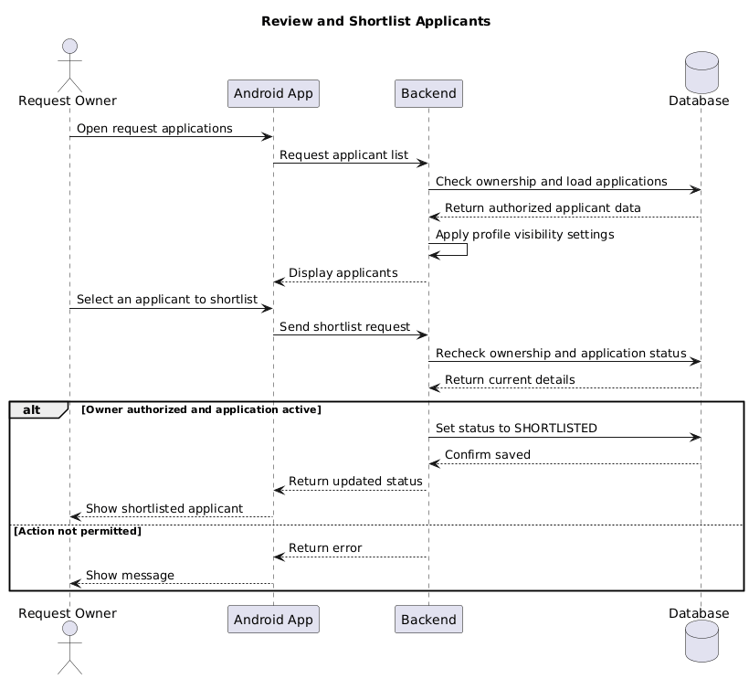
Figure 6. Applicant review sequence showing owner authorization, profile visibility, and shortlist status changes.

8. Use Case Diagram
The diagram shows how students and request owners interact with Takatuf during Sprint 01. It covers account access, profile management, opportunity discovery, publishing, applications, and applicant shortlisting.

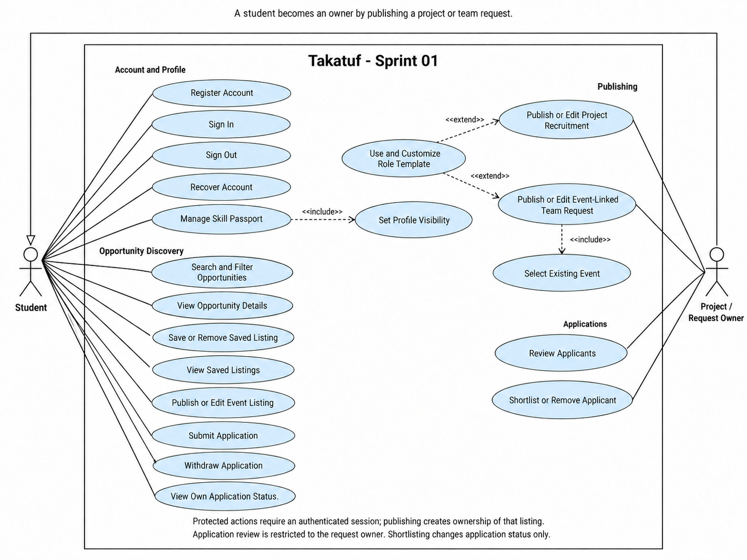
Figure 7. Sprint 01 use case diagram showing student capabilities and the additional responsibilities of project and request owners.

9. Activity Diagram
The diagram illustrates the workflow from discovering an opportunity to submitting and reviewing an application. It includes validation checks, withdrawal, and the owner’s decision to shortlist an applicant.

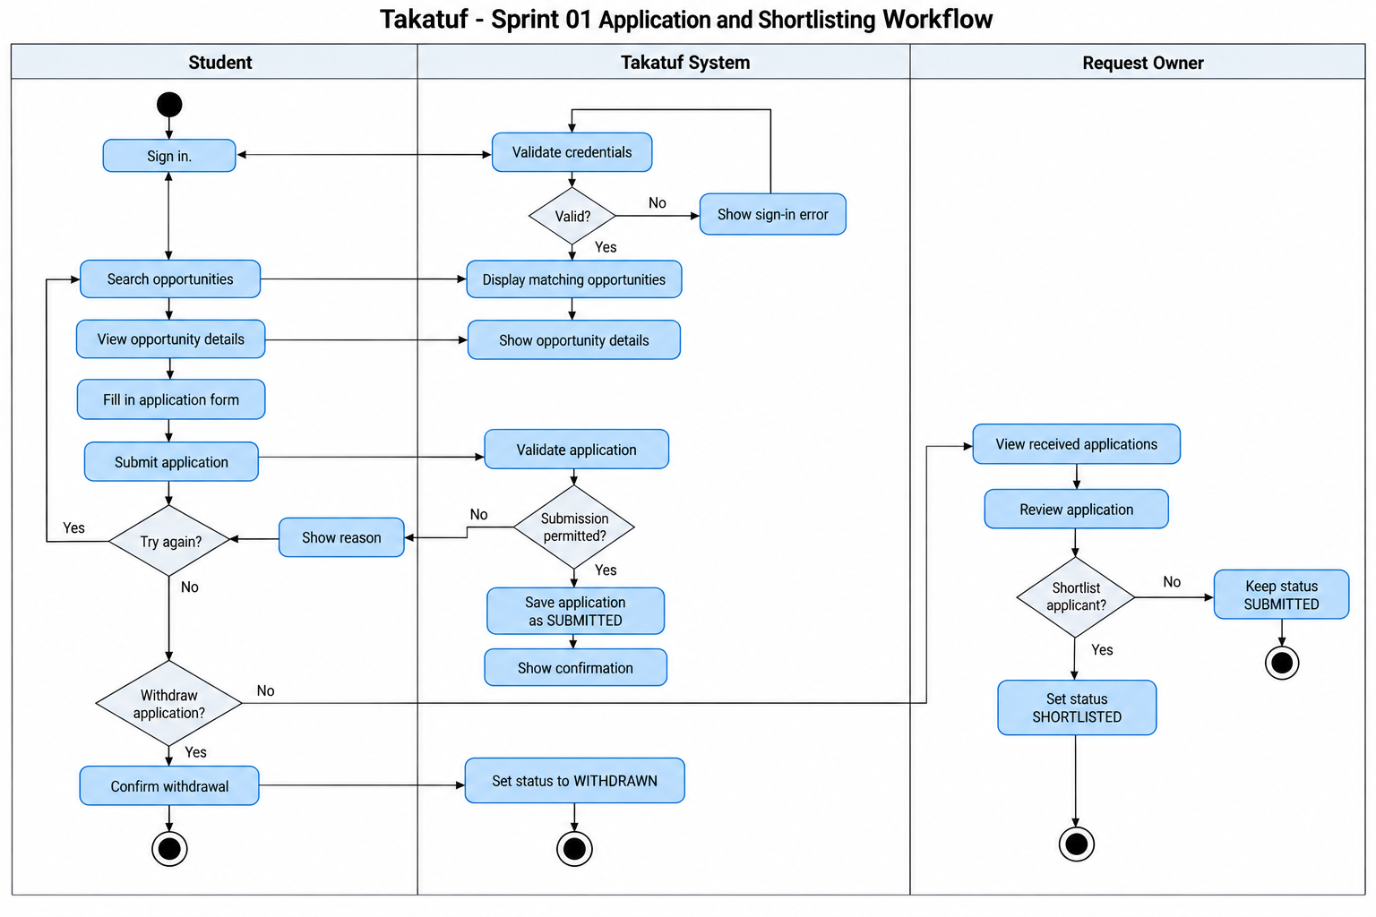
Figure 8. Activity diagram showing application submission, validation, withdrawal, and owner shortlisting during Sprint 01.

10. ERD Diagram
The ERD uses the same entities as the class diagram. Event-specific listing fields and the event reference are nullable where they do not apply. Interests, availability, and required skills initially use structured text fields that the team can refine during implementation.
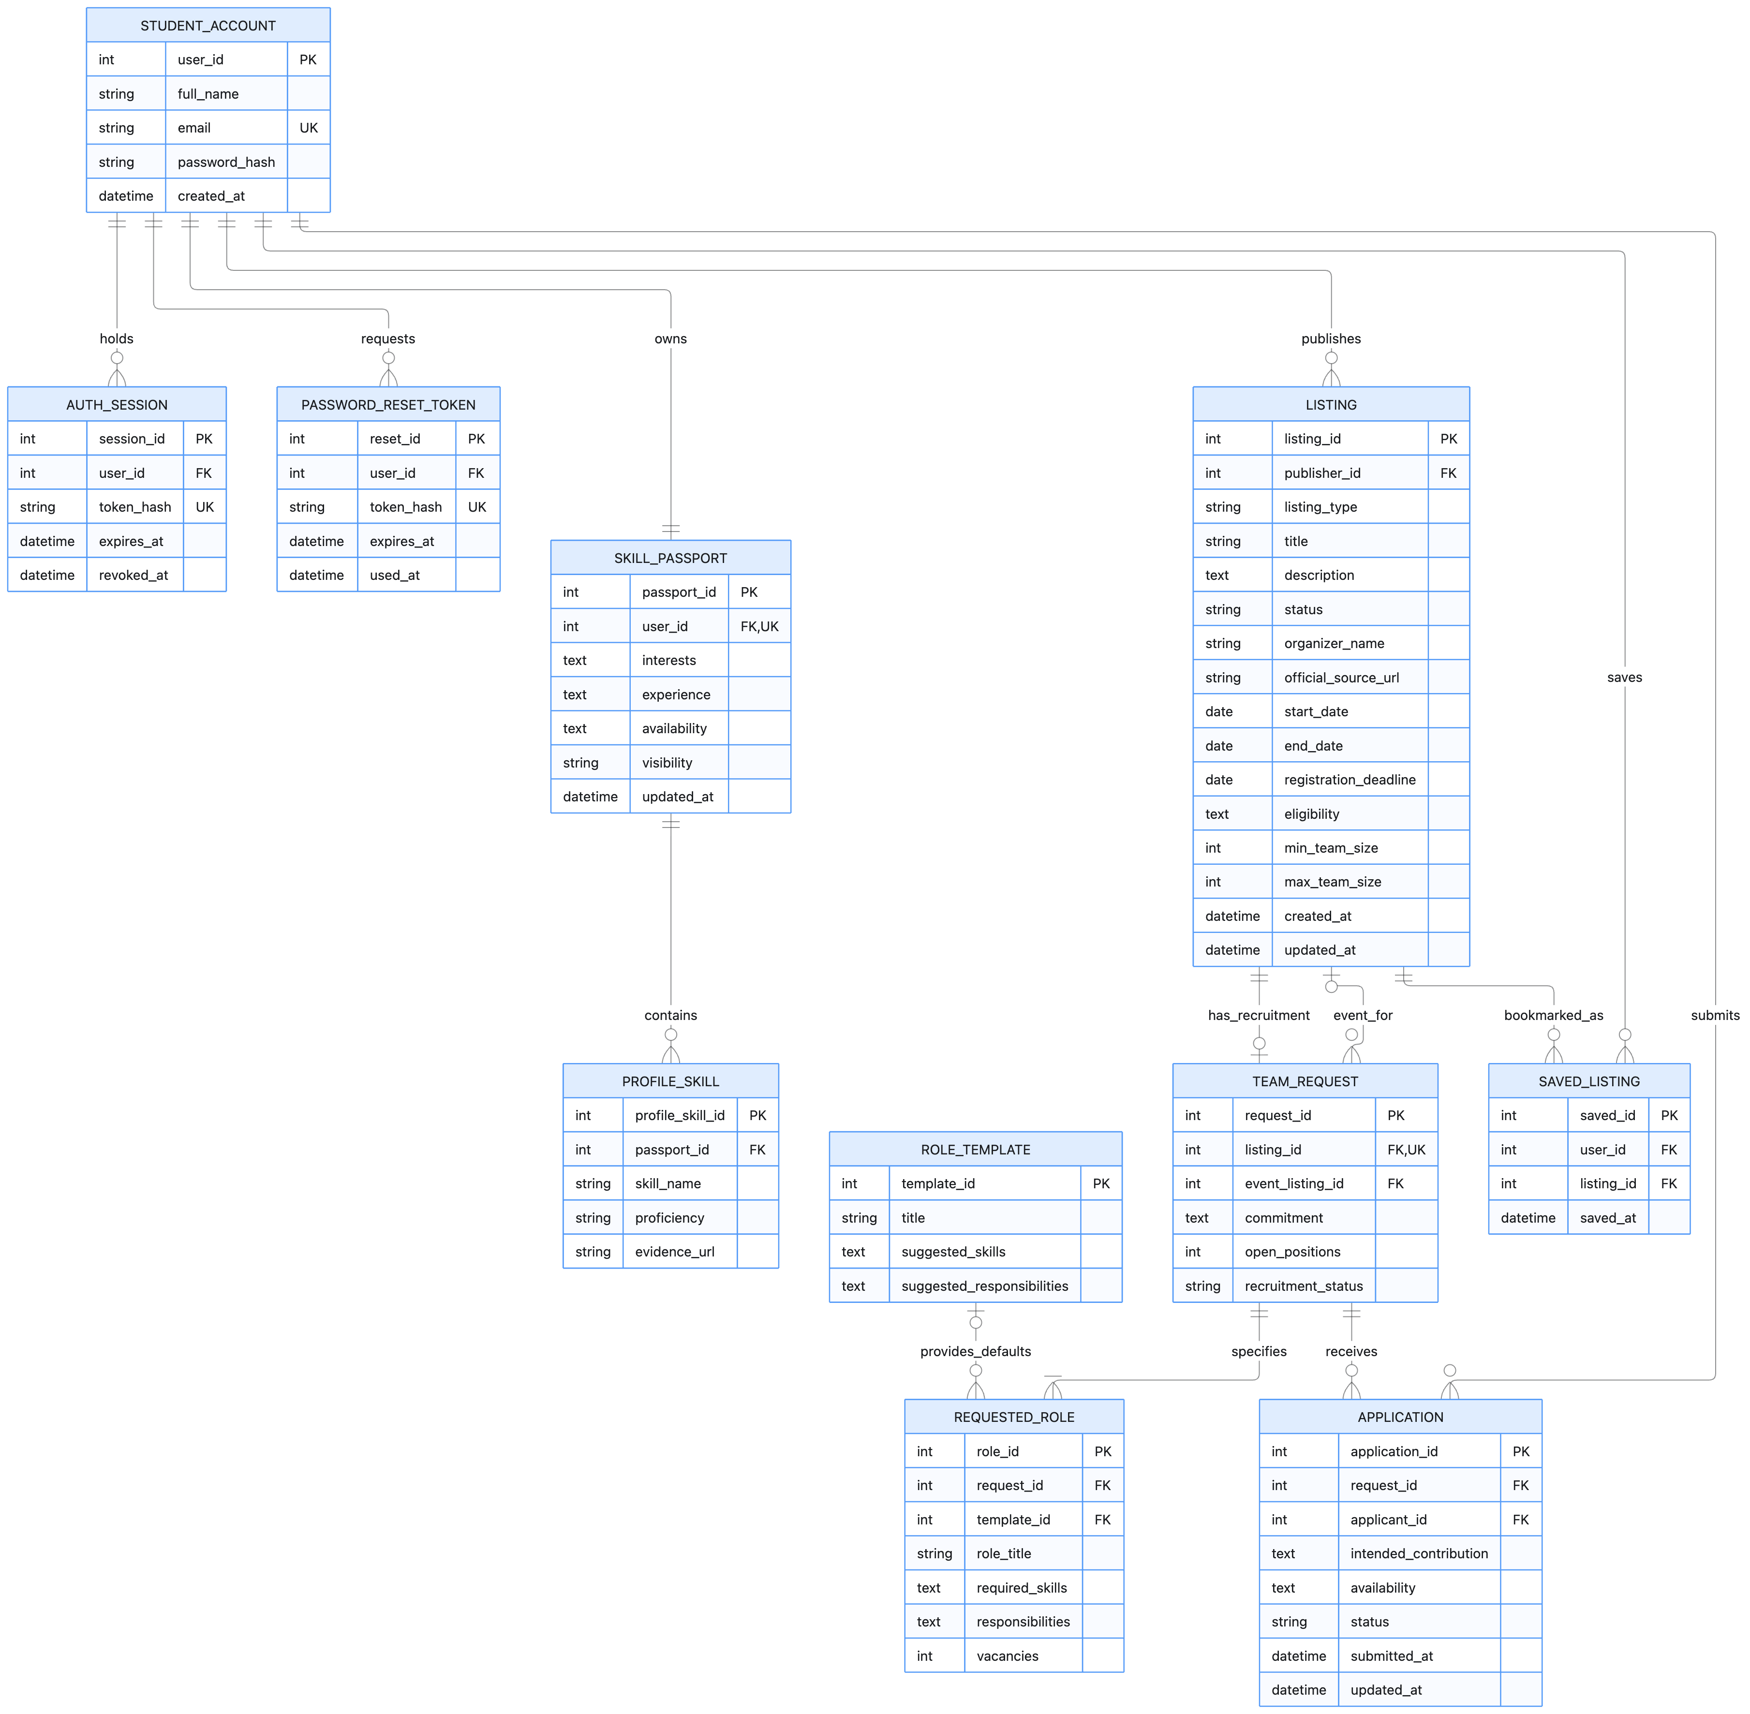

Figure 9. Sprint 01 ERD showing the data required for account access, profiles, opportunity publishing, and initial recruitment.

